DS 522 Data Acquisition and Analytics
HOS08A-1 –Data Visualization
08/25/2024 Revised by Catherine Ata
05/20/2025 Reviewed by Naveena Moddu
04/23/2026 Reviewed by Vishal Krishna Kumar


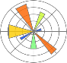



School of Technology & Computing (STC) @ City University of Seattle (CityU)
Take Note Before Starting
- The directory path shown in screenshots may be different from your directory.
- Not every step is explained in the tutorial. If you are not sure what to do:
1. Consult the resources listed below.
2. If you cannot solve the problem after a few tries, email your course TA for help.

Learning Outcomes
- Gain general knowledge regarding the ways to combine DataFrames.
- Understand the distinct types of joins.
- Understand how to concatenate Series and DataFrames
- Understand how to reshape data in Pandas.
- Handling multiple levels of indexes in DataFrames.

Resources
- McKinney. (2022). Python for Data Analysis (3rd edition).
- Tutorials Point. (2024). Python Pandas – Visualization. https://www.tutorialspoint.com/python_pandas/python_pandas_visualization.htm
- API reference. (n.d.). Seaborn. https://seaborn.pydata.org/api.html
- matplotlib.pyplot. (n.d.). Matplotlib. https://matplotlib.org/3.3.1/api/pyplot_summary.html
- rougier. (2021). matplotlib-tutorial. GitHub. https://github.com/rougier/matplotlib-tutorial

Getting Started
- Open VS code and within VS Code, open the DS522 course folder created earlier. On the menu tab, select File, then Open New Folder. Navigate to your work directory or GitHub repository that you have cloned.
Example: C:\ Desktop\DS522 OR C: \Desktop\DS522\github_repository_name
NOTE: If you have cloned a GitHub repository that is provided specifically for this course, navigate to that directory, and skip steps 2 to 4. This will be the folder where you will be storing all your HOS08A work.
- Once in your work directory, go to the menu tab again, select Terminal, select New Terminal to open a Command Line Interface (CLI) like the Command Prompt or PowerShell for Windows OS.
- Inside your “DS522” directory, create a new directory and name it “HOS08A”. Use the following command:
>mkdir HOS08A
- Move to the new directory. Use the following command:
>cd HOS08A
NOTE: This will be the folder where you will be storing all your HOS08A work.
Requirements
For us to perform the tasks in this exercise, we need the following libraries. If you do not have them already, please type the following commands in the terminal to install the required libraries:
Note: Use python3 instead of python if you are on a Mac computer.
• Matplotlib
• Seaborn

Matplotlib
Matplotlib is one of the most popular Python packages used for data visualization. It is cross-platform and the most used Python package for 2D-graphics.
- In your HOS08A folder or repository, create a New File by clicking File on the top menu bar, then New File, and select the Jupyter Notebook option. Save the file with CTRL + S, rename it to data_visualization.ipynb.
- Type the following code and run the code cells to see the output:
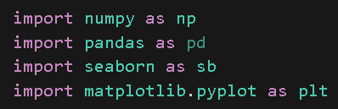
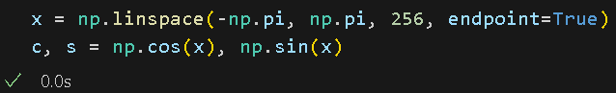
x is a NumPy array with 256 values ranging from -PI to +PI (included). The endpoint=True parameter tells the function to include the last value. c and s are cosine and sine, respectively.
- Let us see how we can plot x, c, and s data. We want to have the cosine data plotted in cyan and the sine data plotted in magenta and a different line style. Type the following code in a new code cell and run it to see the output:
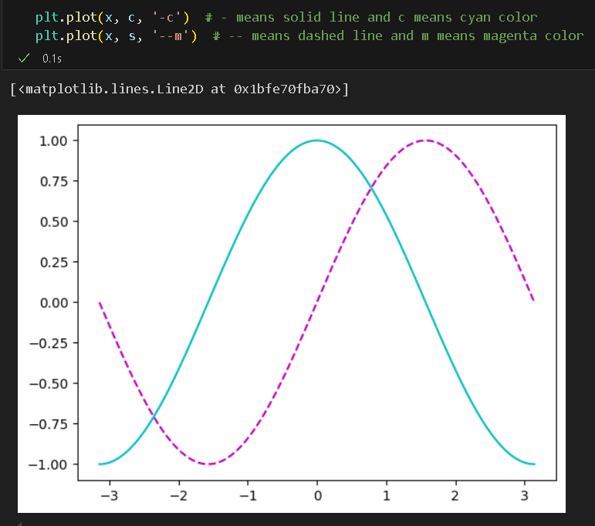
We called the plot function from pyplot to plot the data. In the above example, we used the short form of the parameters, but the code is equivalent to this:
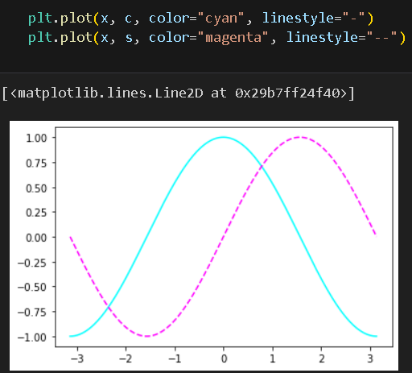
- Next, we will create a figure using the figure() function. Then, we will add axes with
add_axes() and random data about the stock market. Type the following code in a new code cell and run it to see the output:
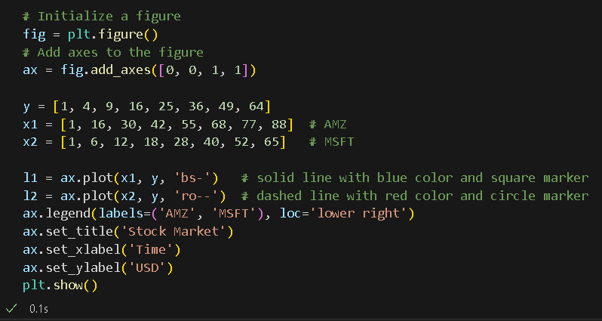
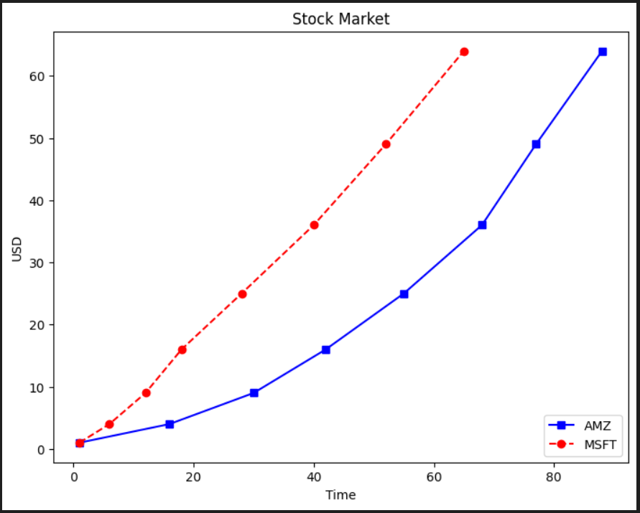
- The array in add_axes() represents the rectangle that has the dimensions of the new axes as follows: [left, bottom, width, height].
- The legend () method places a legend on the figure with labels as defined in the labels parameter and the location specified in the loc parameter (values are ‘upper left,’ ‘upper right,’ ‘lower left,’ and ‘lower right’).
- We can create multiple plots on the same canvas by using the subplot() function which returns the axes object at a given grid position. Type the following code in a new code cell and run it to see the output:
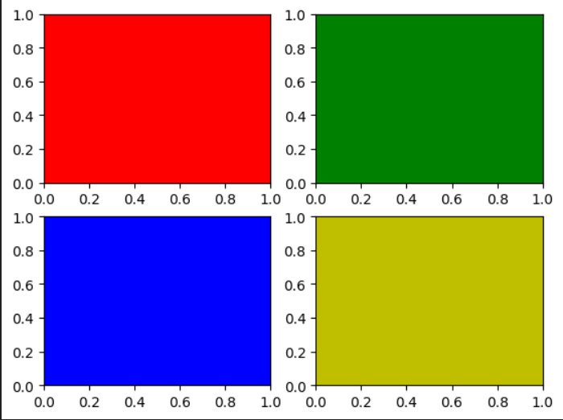
As you can see, we have four subplots in the figure. The number of arguments in the subplot function represent row, column, and position. subplot (2, 2, 1) means we are putting the subplot at position 1 (top-left) in the 2 row-2 column figures.

Note that creating a subplot will delete any pre-existing subplot that overlaps it beyond sharing a boundary. To avoid overlap behavior, use add_subplot() instead.

- Now we will add a subplot inside a subplot using add_subplot() as just mentioned, so we do not overwrite the first subplot. Type the following code in a new code cell and run it to see the output:
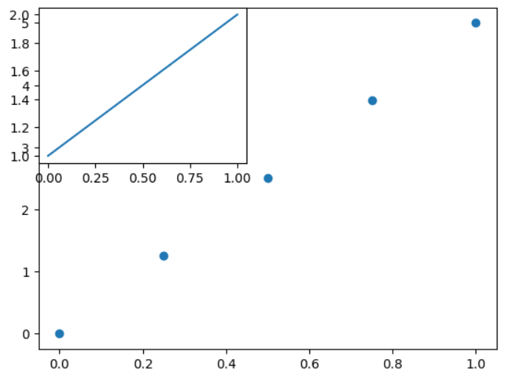
We got the output we expected, but the scale on the left side is messy since it is shared by both plots.

- A workaround to the previous problem would be to use add_axes() as in the following example. Type the following code in a new code cell and run it to see the output:
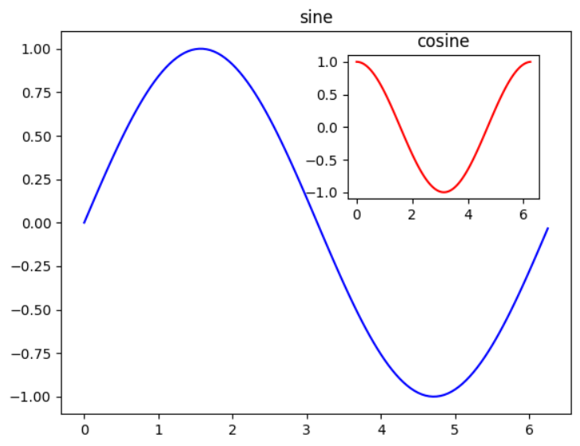
The difference between add_axes() and add_subplot() is the absolute coordinates we passed in while add_subplot() does not have the option to put axes at a certain position.

Let us look at several types of visualization plots that are commonly used.

- First, we will implement a heat plot. Note that imshow() is used to display data as an image. Type the following code in a new code cell and run it to see the output:

- Next, we will create a contour plot. Type the following code in a new code cell and run it to see the output:

- We can also create scatter plots. Type the following code in a new code cell and run it to see the output:
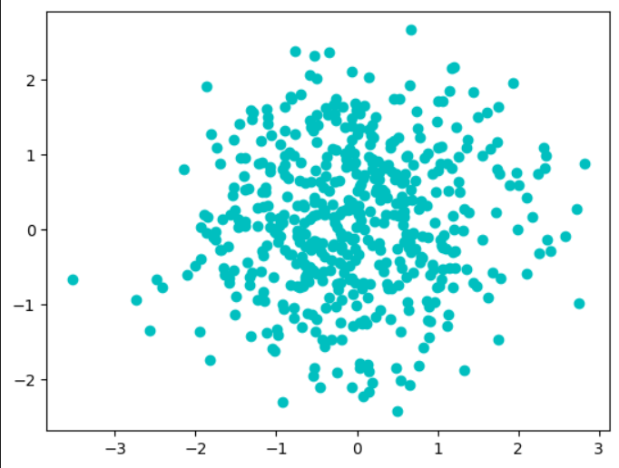

- Next, we will explore bar plots and various parameters that can be set. Type the following code in a new code cell and run it to see the output:
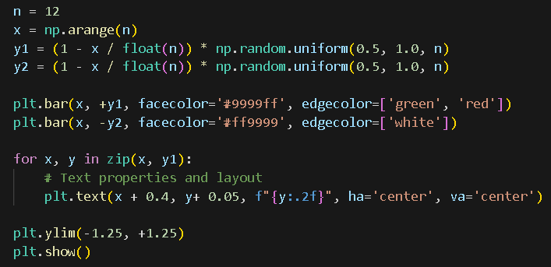
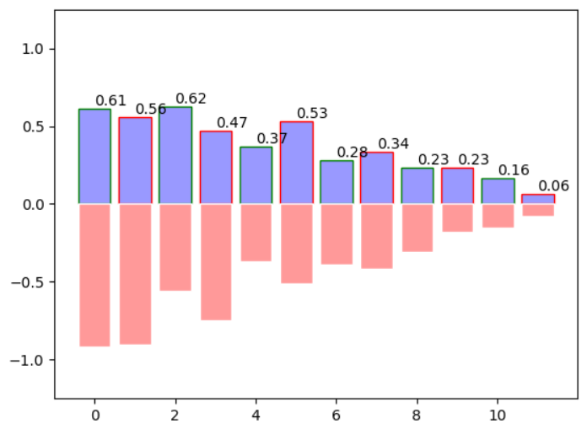

- Finally, we will implement a 3D plot. Type the following code in a new code cell and run it to see the output:

To learn more about matplotlib, check this link: https://matplotlib.org/3.3.1/index.html.

Seaborn
Seaborn is a library used for making statistical graphics in Python. It is built on top of matplotlib and tightly integrated with pandas’ data structures.

Some of the functionality that seaborn offers include:
• Built-in themes for styling matplotlib graphics
• Visualizing univariate and bivariate data
• Fitting and visualizing linear regression models
• Plotting statistical time series data
• Seaborn works well with NumPy and Pandas data structures

Let us go ahead and create some data visualizations using Seaborn.

- First, we will load the “tips” dataset provided by Seaborn. (To see additional datasets, you can use sb.get_dataset_names()). The following plot will show the relationship between two variables. Type the following code in a new code cell and run it to see the output:
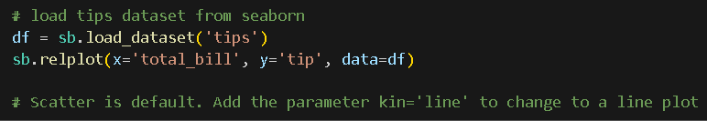

- Next, let us add more dimension to the plot by using data hue. Type the following code in a new code cell and run it to see the output:
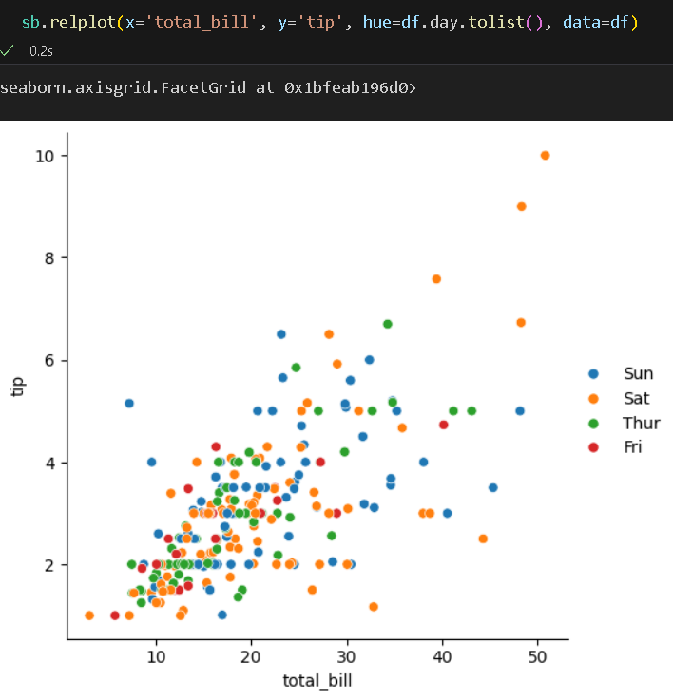
The hue parameter groups variables and produces points with assorted colors.

- There are many more customizations that we can try out with Seaborn such as colors, styles, sizes, etc. Type the following code in a new code cell and run it to see the output:
As you can see, we set the style and the color palette to white gride and green, respectively.

- There are MANY colors that you can customize except for the default ones – let us try some out. Type the following code in a new code cell and run it to see the output:
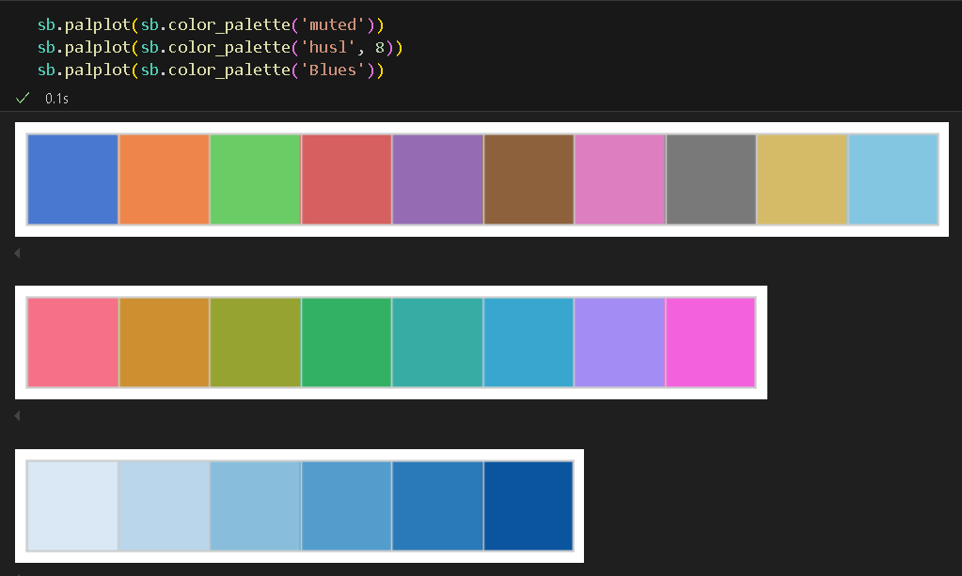

- We can plot categorical data when our main variable is divided into discrete groups. Type the following code in a new code cell and run it to see the output:
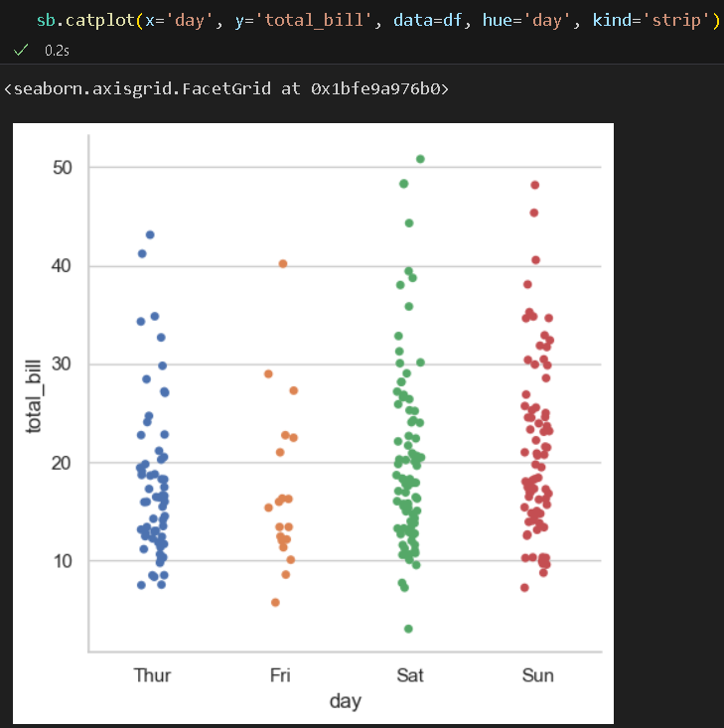

- We can also plot univariate distributions using the displot() function. Distribution of data is one of the most important things to understand when analyzing data. Type the following code in a new code cell and run it to see the output:
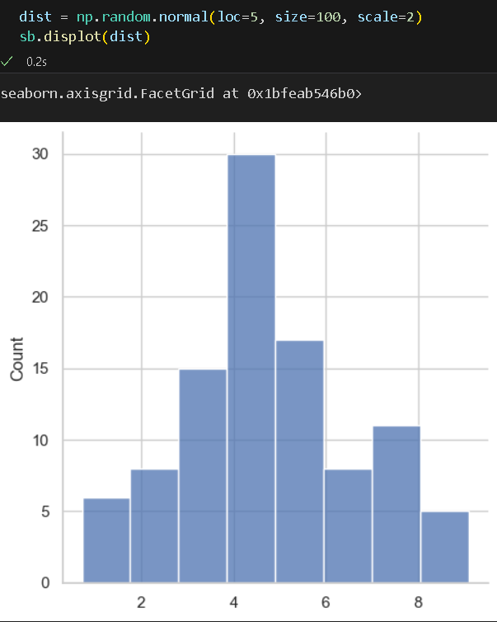

- Seaborn also allows you to plot multiple grids side-by-side. This helps to differentiate between the plots and obtain substantial amounts of information. FacetGrid() helps in visualizing the distribution of one variable as well as the relationship between multiple variables. Type the following code in a new code cell and run it to see the output:
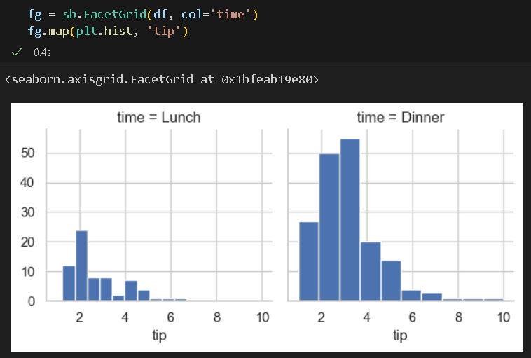

- Like FacetGrid(), PairGrid() uses a different pair of variables for each subplot. It has more flexibility than pairplot which does basically the same thing, but easier. Type the following code in a new code cell and run it to see the output:
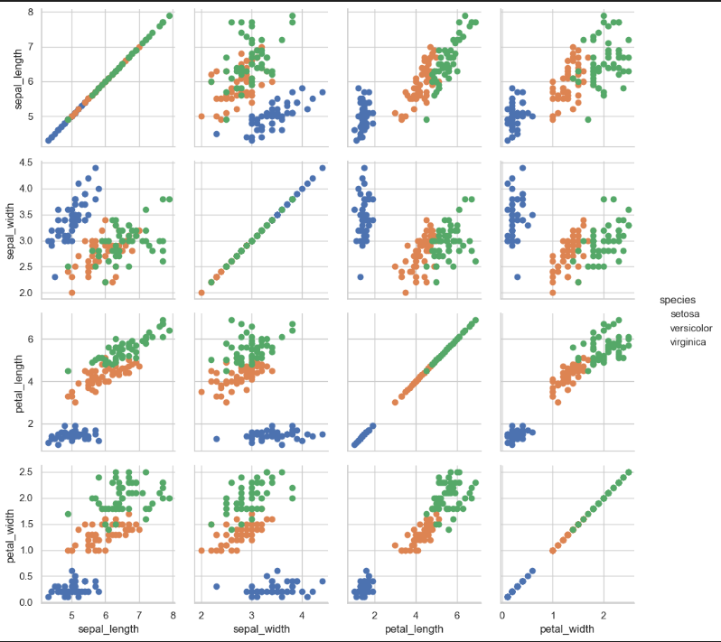

- Finally, let us implement a heatmap. Type the following code in a new code cell and run it to see the output:
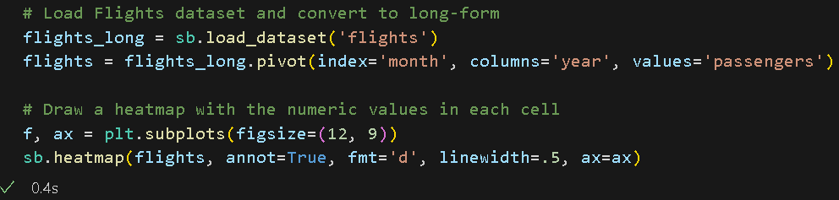
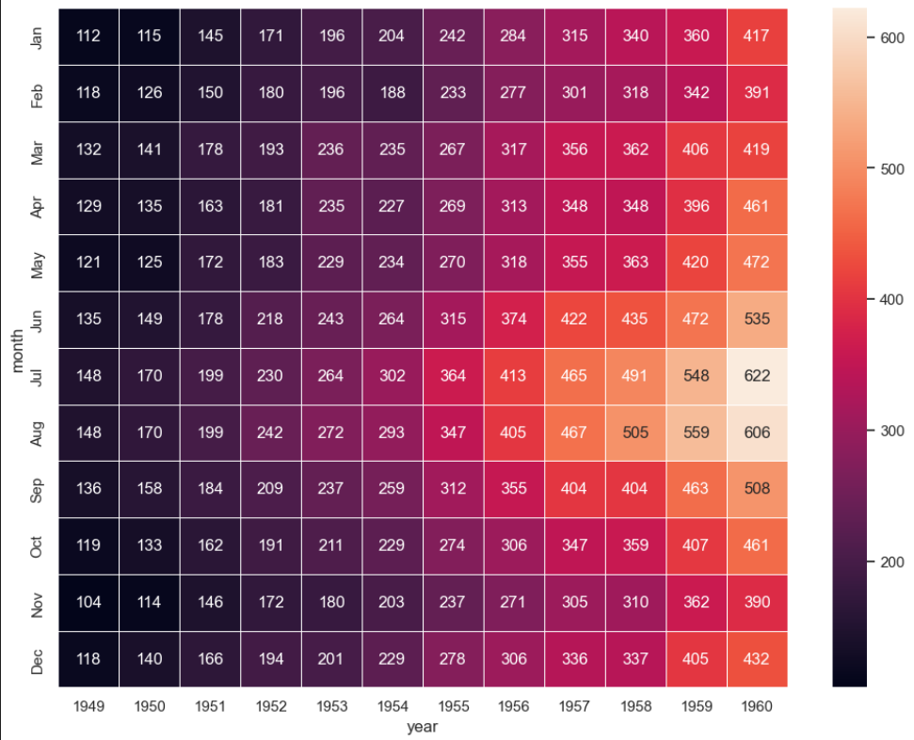
Here, annot=True writes the data value in each cell, and fmt is used to set string formatting when adding annotations.

To learn more about Seaborn, check this link: https://seaborn.pydata.org/tutorial.html.
*** This is the end of the HOS8A-1 exercise. Please proceed with working on HOS8A-2 and answer HOS08B in Brightspace after pushing your work to GitHub. ***

Push your work to GitHub.
Follow the instructions on the CityU STC TA Center Github.io Submit your work page

You may also follow the instructions below:
1. Open the cmd terminal for Windows users,
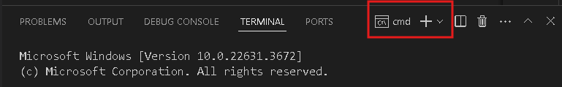

2. After selecting the + button, make sure the terminal is cmd if you have not closed the Python terminal.

If the terminal is not cmd, then you need to add it by opening the drop-down box, choose the Select Default Profile.
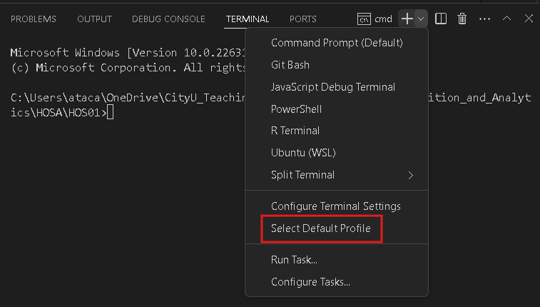

Look for and then select Command Prompt
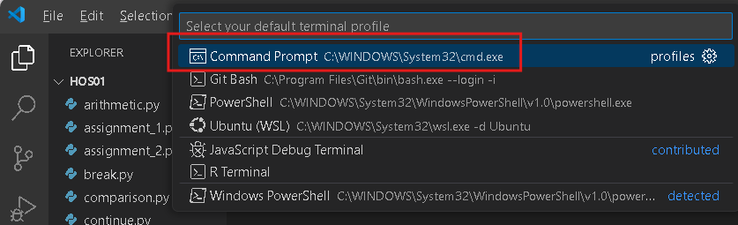

Click the + button. The command prompt will open.

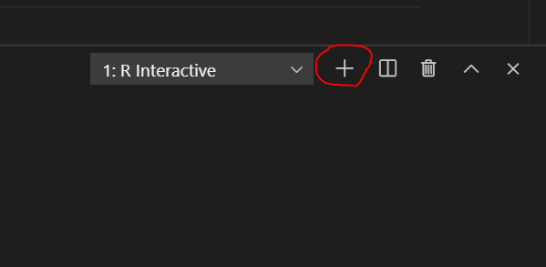

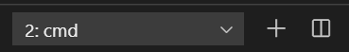

3. Make sure you are in the correct directory/repository: Desktop/DS522/hos08a-courseName-yourUserName

Run the following commands to push your work to the GitHub repository:
Open the terminal from the VSCode by hitting the control + ~ key and type the following command:
>>> git add .
>>> git commit -m “Submission for HOS08A-1.”
>>> git push

